Cost Management Process©
For [Project Name]

Document Control

Document Information
© | Information
Document ID | [Document Management System #]
Document Owner | [Owner Name]
Issue Date | [Date]
Last Saved Date | [Date]
File Name | [Name]

Document History
Version | Issue Date | Changes
[1.0] | [Date] | [Section, Page(s) and Text Revised]

Document Approvals
Role | Name© | Signature | Date
Project Sponsor

Project Review Group

Project Manager©

Quality Manager
[if applicable]

Procurement Manager
[if applicable]

Communications Manager
[if applicable]

Project Office Manager
[if applicable]

Table of Contents

1 Cost Management Process 1
1.1 Overview 1
1.2 Document Expense 2
1.3 Approve Expense 2
1.4 Update Project Plan 2
2 Cost Management Roles 2
2.1 Team Member 2
2.2 Project Administrator 2
2.3 Project Manager 2
3 Cost Management Documents 2
3.1 Expense Form 2
3.2 Expense Register 3

Cost Management Process

Document the process for monitoring and controlling costs on a project by completing this template.

Overview

Provide an overview of the Cost Management Process, depicted as follows:

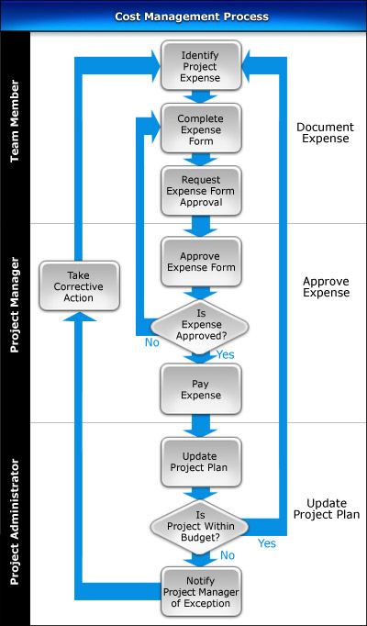

Document Expense

List the steps required to identify expenses, complete Expense Forms and request their approval by the Project Manager.

Approve Expense

Describe the process of reviewing the Expense Forms submitted and determining whether expenses should be approved or declined based on available information. List the steps required to authorize an expense payment after an Expense Forms has been approved.

Update Project Plan

Identify the procedures involved in updating the Project Plan with the expense information and determining whether or not the project is currently operating “within budget”. Also describe the steps involved in keeping the Expense Register up-to-date throughout the Project Lifecycle.

Cost Management Roles

In this section, describe the key roles and responsibilities in undertaking the Cost Management Process.

Team Member

List the responsibilities of the Procurement Manager in the Cost Management Process.

Project Administrator

List the responsibilities of the Project Administrator in the Cost Management Process.

Project Manager

List the responsibilities of the Project Manager in the Cost Management Process.

Cost Management Documents

In this section, identify the documents used to successfully undertake the Cost Management Process.

Expense Form

Describe the purpose of the Expense Form and provide a template for its completion.

Expense Register

Describe the purpose of the Expense Register and provide a template for its completion.

